Read and Understood WordPress Plugin Test Plan

Author: Peter Mantos; Mantos I.T. Consulting, Inc.

Revised: 02-Dec-2017

The test plan consists of multiple cases designed to be executed sequentially. RnU supports the current versions Microsoft Internet Explorer, Mozilla FireFox, and Google Chrome Browsers. Other browsers and versions of browsers may be tested using this plan, but failure on unsupported browsers or other versions does not constituent failure of a release of RnU. In addition to the three supported browsers, RnU functions with or without Javascript being enabled. When running the test suite, please record the Version of WordPress being used in the test, the name and version of the browser being used, and whether or not JavaScript is enabled for the browser.

Contents

Installation Test Suite 2

Operation Test Suite 2

Case #1 – Settings Page Conflicts 2

Case #2 – Category Settings 2

Case #3 – “Courtesy Name” settings appear depending on “Require Login” checkbox 3

Case #4 - “Require Login” check box is saved 3

Case #5 – Test Default Username validation on Settings page 3

Case #6 – Test date format and ranges on Settings page 4

Case #7 – Test acknowledgement while NOT logged on to WordPress site 6

Case #8 – Test acknowledgement while logged on to WordPress site 8

Case #9 – Test Export & Purge functions 9

Upgrade Test Suite 10

Deactivation Test Suite 10

Uninstallation Test Suite 10

Known issues: 11

# Installation Test Suite

TODO

# Operation Test Suite

This suite assumes that RnU has been installed and that the Installation Test Suite (not yet developed) passed.

## Case #1 – Settings Page Conflicts

1. Login to WordPress Administrator Account
2. Ensure that Read and Understood Plugin is installed and activated
3. Go to Settings, Read and Understood

Expected result: No warnings or errors indicating that Plugin loaded properly. Screen Should appear as:

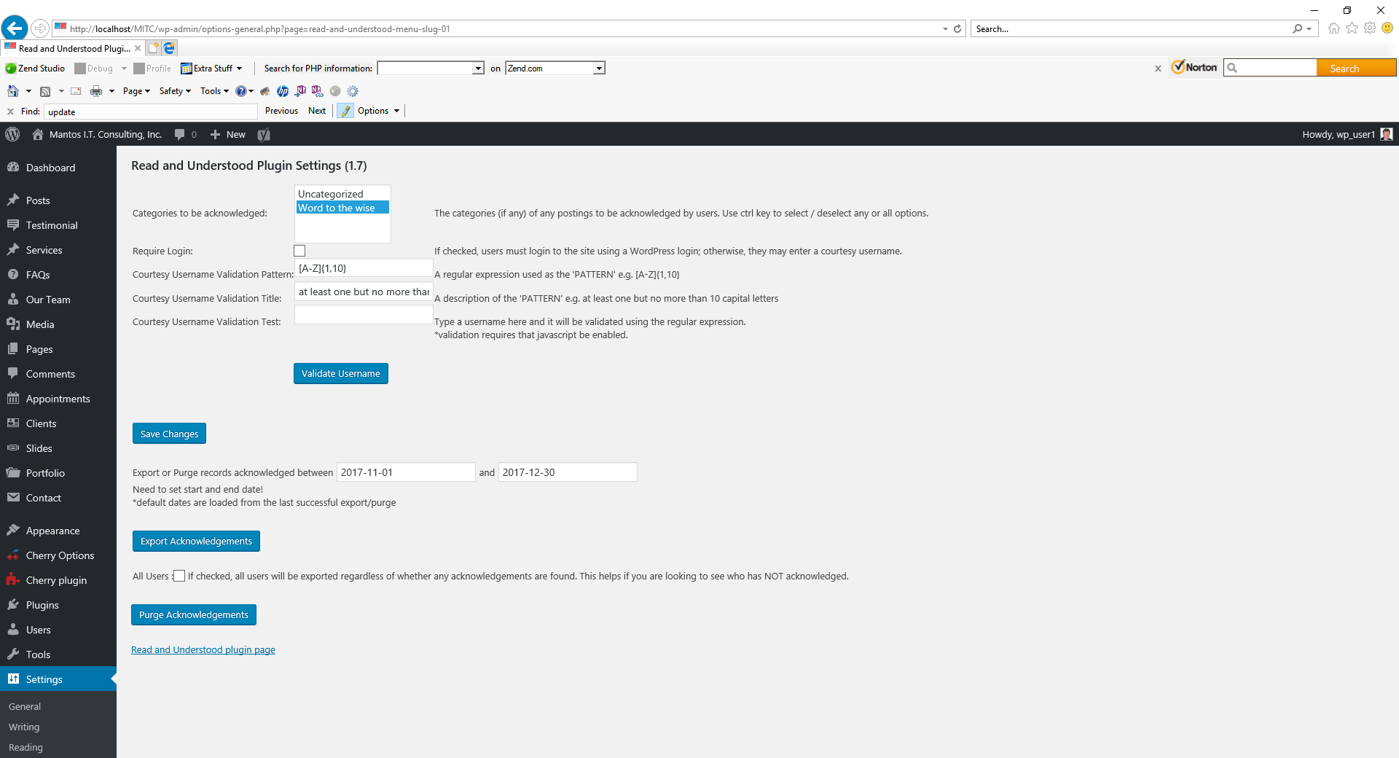

## Case #2 – Category Settings

Assumptions: More than one category exists on the WordPress site. If not the case, add categories using the Admin Screen => Posts => Categories => Add New Categories feature

1. Record (write down) the “Categories to be acknowledged” selected so that you may restore it after selecting another below.
2. Pick a different set of categories (if only 1 category “uncategorized”, repeat test after adding additional categories)
3. Press Save Changes button

Expected result: “Settings Saved” message appears and categories chosen appears in the pull-down menu as the default/selected value

1. Deselect all categories (using the ctrl-click)
2. Press Save Changes button

Expected result: Settings Saved” message appears no categories appears as highlighted in the pull-down menu as the default/selected value

1. Pick the original categories
2. Press Save Changes button

Expected result: Settings Saved” message appears and original category chosen appears in the pull-down menu as the default/selected value

## Case #3 – “Courtesy Name” settings appear depending on “Require Login” checkbox

1. Toggle (Check and Uncheck) “Require Login” check box

Expected result: If JavaScript is on, the three “Courtesy Username …” fields, titles, and descriptions should disappear when checkbox is checked and reappear when checkbox is unchecked; otherwise, no change expected.

## Case #4 - “Require Login” check box is saved

1. Toggle “Require Login” check box and
2. use “Save Changes” button between changes to save “Require Login” setting
3. Repeat steps 1-2 (to test “Checked” and “unchecked”

Expected result:

1. The three “Courtesy Username …” fields, titles, and descriptions should disappear and reappear when checked if JavaScript is on.
2. The page will reload
3. The “settings saved” message should appear near the heading.
4. “Require Login” setting will be set as when saved
5. The three “Courtesy Username …” fields, titles, and descriptions should disappear and reappear when checked if JavaScript is on.

## Case #5 – Test Default Username validation on Settings page

1. Ensure that “Require Login” check box is not checked
2. Ensure that Courtesy Username Validation Pattern reads “[A-Za-z]{1,10}”
3. Ensure that Courtesy Username Validation Title reads “1 to ten letters (case sensitive)”
4. Type “aWW” into the username box
5. Click outside the username box (such as on whitespace)

Expected result: None, indicating validation success.

1. Return “aWW#er1#” into the username box
2. Click outside the username box (such as on whitespace)

Expected result: If JavaScript is on, an alert should appear with message that username does not match pattern. Otherwise, no change.

1. Press “enter” in alert box, if displayed (Expect it to go away)
2. Press backspace multiple times to clear box (expect no warnings or errors)
3. Type ABCDEFghijk into username box
4. Click outside the username box (such as on whitespace)

Expected result: If JavaScript is on, an alert should appear with message that username does not match pattern. Otherwise, no change.

1. Click “OK” in alert box alert box, if displayed (Expect it to go away)
2. Press backspace multiple times to clear box (expect no warnings or errors)
3. Type ABCDEFghij into username box
4. Click outside the username box (such as on whitespace)

Expected result: None, indicating username matches pattern.

1. Press “Validate Username”

Expected result: **Username: "ABCDEFghij" matches the pattern: [A-Za-z]{1,10}** message near header after page reload. Username box clears.

1. Type ABCDEFghijK into username box
2. Press “Validate Username”

Expected result: **Username: "ABCDEFghijK " does not match the pattern: [A-Za-z]{1,10}** message after after page reload. Username box clears.

## Case #6 – Test date format and ranges on Settings page

1. Click in the Start Date Field

Expected Result: If JavaScript is enabled, a well formatted date picker appears.

1. If JavaScript is enabled, pick any Start Date otherwise enter any valid date in YYYY-MM-DD format.

Expected Result: If JavaScript enable, the Start Date Field (on left) is populated with selected or entered start date in YYYY-MM-DD format. Otherwise, no change

1. Click in the End Date Field

Expected Result: If JavaScript is enabled, a well formatted date picker appears.

1. Pick or enter the same date as used for the Start Date

Expected Result: End Date field (on right of the date range) is populated with selected or entered start date in YYYY-MM-DD format

1. Click Export button

Expected result: Either a warning “No records to export” or a download dialog. (Other cases will specifically test for both those conditions). If download dialog, cancel it.

1. Select an End Date that occurs before the previously selected Start Date
2. Click Export button

Expected result: A warning “Start date may not be after end date.”

1. Delete (blank out) the end date (leaving the start date)
2. Click Export

Expected result: A warning “Need to set start and end date!.”

1. Select an End Date
2. Delete (blank out) the start date (leaving the end date)
3. Click Export

Expected result: A warning “Need to set start and end date!.”

1. Delete (blank out) both the Start Date and the End Date
2. Click Export

Expected result: A warning “Need to set start and end date!.”

1. Select valid end date
2. Delete (blank out) the Start Date
3. Type into the start date 5 digits and then some letters

Expected Result: If JavaScript is enable, digits are displayed, letters ignored; otherwise, text entered is displayed.

1. Press Export

Expected result: A warning “Error: Dates should be in yyyy-mm-dd format.”

1. Select valid Start date
2. Delete (blank out) the End Date
3. Type into the End date 5 letters and then 5 digits and then some letters

Expected Result: digits are displayed, letters ignored

1. Press Export button

Expected result: A warning “Error: Dates should be in yyyy-mm-dd format.” Both Start and End dates revert to defaults.

1. Select or enter a Valid end date
2. Delete (blank out) the Start Date
3. Type into the Start date 5 letters and then 5 digits and then some letters

Expected Result: If JavaScript is enable, digits are displayed, letters ignored; otherwise, text entered is displayed.

1. Press Export button

Expected result: A warning “Error: Dates should be in yyyy-mm-dd format.” Both Start and End dates revert to defaults

1. Select or enter in yyyy-mm-dd format, an End Date that comes before the displayed (default) Start Date
2. Press Export button

Expected Result: “Start date may not be after end date” message is displayed.

## Case #7 – Test acknowledgement while NOT logged on to WordPress site

Prereqs:

1. Set RnU Settings by logging on as WordPress admin and using RnU settings page)
   1. The category should be set to one for which at least one non-private posting exists on the website (create posts and categories as necessary)
   2. The settings should NOT “require login”
   3. Ensure that Courtesy Username Validation Pattern reads “[A-Za-z]{1,10}”
   4. Ensure that Courtesy Username Validation Title reads “1 to ten letters (case sensitive)”
   5. Purge any existing acknowledgement records for the current day using the PURGE function
2. Ensure that no acknowledgements exist for ‘today’ in the database. You may use the PURGE function on the RnU settings page (while logged-in WP administrator) using today as both Start Date and the End Date (or use the MySql Workbench or PhpAdmin to delete any records.)
3. Log off the WordPress Site so that the user is NOT logged-in.

Test Procedure:

1. Navigate to any page that displays a posting that is in the category specified in Pre-req step 1a

Expected Outcome: The READ AND UNDERSTOOD button appears on the page after the contents of posting. The Username box and the login/logout link appear as well

1. Type “aWW” into the username box
2. Click outside the username box (such as on whitespace)

Expected result: None, indicating validation success, if JavaScript is on.

1. Cut and paste “aWW#er1#” into the username box
2. Click outside the username box (such as on whitespace)

Expected result: If JavaScript is enabled, an alert should appear with message that username does not match pattern. Otherwise, the browser may highlight the box in red indicating that the contents are not valid for the pattern.

1. If the alert box is displayed, press “enter” in alert Box (Expect it to go away)
2. Press backspace multiple times to clear box (expect no warnings or errors)
3. Type ABCDEFghijk into username box
4. Click outside the username box (such as on whitespace)

Expected result: If JavaScript is enabled, an alert should appear with message that username does not match pattern. Otherwise, the browser may highlight the box in red indicating that the contents are not valid for the pattern.

1. If the alert box is displayed, press “enter” in alert Box (Expect it to go away)
2. Press “Read and Understood” button

Expected result: If JavaScript is enabled, processing will occur without reloading the page. Otherwise, the browser may not submit the form and give a “Please match the requested format” message (at least in Firefox). In any case, the page should display a text message that includes ‘enter a Username that matches the pattern’.

1. Press backspace multiple times in the username text box in order to clear it. (expect no warnings or errors)
2. Type ABCDEFghij into username box
3. Click outside the username box (such as on whitespace)

Expected result: None, indicating that the username matches pattern

1. Press “Read and Understood” button

Expected result: The page will reload unless JavaScript is on. The page should then display the text “You have acknowledged this posting” in green text. The “Read and Understood” button as well as the Login/logout link should disappear.

1. Refresh same page/posting using browser control

Expected Outcome: the READ AND UNDERSTOOD button appears on the page and the empty Username box and the login/logout link appear as well

1. Repeat steps 13-16 three times using the usernames BOB, MARY, and TED (instead of ABCDEFghij) to record acknowledgements.

Expected result: “You have acknowledged this posting” in green text for each of the three entries

## Case #8 – Test acknowledgement while logged on to WordPress site

Prereqs:

1. Set RnU Settings by logging on as WordPress admin and using RnU settings page)
   1. The category should be set to one for which at least one non-private posting exists on the website (create posts and categories as necessary)
   2. The settings should “require login”
2. Ensure that no acknowledgements exist for ‘today’ in the database other than those entered in previous test cases. You may use the PURGE function on the RnU settings page (while logged-in WP administrator) using today as both Start Date and the End Date (or use the MySql Workbench or PhpAdmin to delete any records.)
3. Ensure that at least one user is authorized to log into the WordPress site and that you have access to that username and password. You may use the default WP admin account for this test or you may enter another username using the Users=>Add New function of the WordPress Admin page.

Test Procedure:

1. Log in to WordPress
2. Navigate to any page that displays a posting that is in the category specified in Pre-req step 1a

Expected Outcome: The READ AND UNDERSTOOD button appears on the page after the contents of posting. The Username box and the login/logout link do NOT appear.

1. Press “Read and Understood” button

Expected result: The page will reload unless JavaScript is on. The page should then display the text “You have acknowledged this posting” in green text.

1. Refresh same page/posting using browser control

Expected Outcome: The READ AND UNDERSTOOD button does NOT appear (nor do the Username box nor the login/logout link appear.) The page should display the text “You have acknowledged this posting” in green text.

1. Log out of WordPress
2. Optional: Repeat steps 1-5 logging in using other available usernames.

## Case #9 – Test Export & Purge functions

(assumes Case 6 has been run to store data for today’s date)

1. Login as WordPress administrator
2. Go to RnU Settings page
3. Set Start Date and End Date to today
4. Press Export

Expected result: CSV file is downloaded

1. Open CSV file using Notepad or a Spreadsheet program

Expected result: CSV file with headers and a row for each record entered in step 6 (possibly more records if other acknowledgements had been made).

1. Headings should be: **** See: KNOWN ISSUE that header row is sometimes blank***
   1. RNU_USERNAME
   2. post_title
   3. idRNU_ACKNOWLEDGMENT
   4. RNU_USER_ID
   5. RNU_POST_ID
   6. RNU_ACK_DATETIME”
2. For each acknowledgement record entered under case #6
   1. userid should be 0,
   2. date should be today’s
3. Count number of records in the downloaded file (excluding the header row) as that number will be used during purge test below
4. Close CSV file
5. Refresh Settings page

Expected result: Start and end dates remain set at today’s date indicating that they are the new defaults stored as options.

1. Press Purge Acknowledgments button

Expected result: The purge button is replaced by “Confirm Purge” button that displays the number of record that were shown in the exported CSV file

1. Change End date to tomorrow

Expected Result: If JavaScript is enabled, the “Confirm Purge” button should revert to Purge Button.

1. Unless changed by JavaScript back to a simple “Purge” button, Press “Confirm Purge” button; otherwise, do not press the “Purge” button displayed and proceed to step 12.

Expected result: No records are purged (indicated by the lack of XXX records purged message) and the “Confirm Purge” button goes back to the normal “Purge” button. The dates revert to what they were the “Purge” (not “Confirm”) button was pressed.

1. Verify or change the End Date back to today
2. Press Purge Acknowledgments button

Expected result: Purge button is replaced by “Confirm Purge” button that displays the number of record that were shown in the exported CSV file

1. Press “Confirm Purge” button

Expected result: Purge button replaces the “Confirm Purge” button and a text acknowledgment that displays the number of record that were shown in the exported CSV file is displayed below the button

1. Press Purge Button

Expected result: No change – no records are left to be purged. Text displaying the number of records purged disappears.

1. Press Export Button

Expected result: “Warning: no records to export …”

# Upgrade Test Suite

Significant changes to the database were made between version 1.6 and 1.7 . these changes include:

1. Adding a new rnu_categories table to store multiple categories as selected in the options page by the admin.

# Deactivation Test Suite

# Uninstallation Test Suite

# Known issues:

1. Sometimes, using Chrome and perhaps in other browsers, the header row of the CSV file appears blank when automatically opened using Microsoft eXcel 2010. Hitting export again shows the download with the headers.